“ I beheld theBeast, the Monster, I had created “
Mary Shelley Frankenstein

The following design Guide for a simple PID Controller is loosely based around the

following Atmel App Note and various related Articles found on the Web

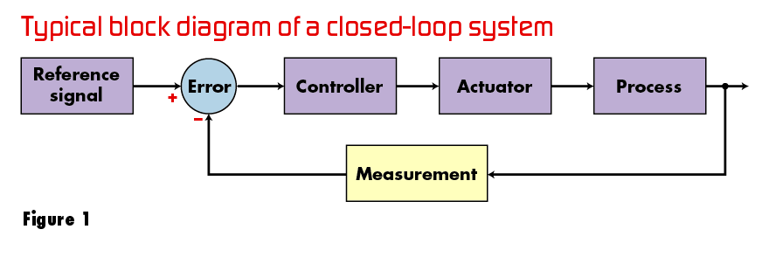
Classic PID Controller.

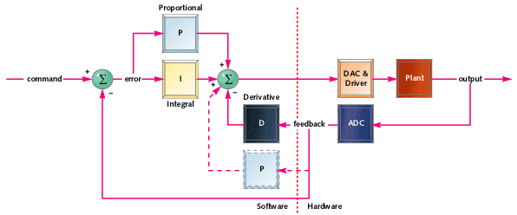
Figure 2

To test this theory and to get a hands on feel for this technology, I decided to build the PWM

Accumulator charger shown below in Figure 3

A Tiny13, running at an internal clock rate of 9.6 Mhz, lies at the heart of this circuit..

The Set point reference voltage is set @ 5.25 Volts and this is constantly compared to the divided

down voltage at the output of the circuit. This Error signal, suitably modified, is used to generate the

Proportional Integral Derivative components of the algorithm and thereby modiy the Pulse Width

Modulator output pulse train. The Internal 1.1 volt reference sets the necessary Voltage span.

The attached code in Pid.asm is optimised for speed and minimum bloat size, is

extensively commented and should be easy to modify for different applications.
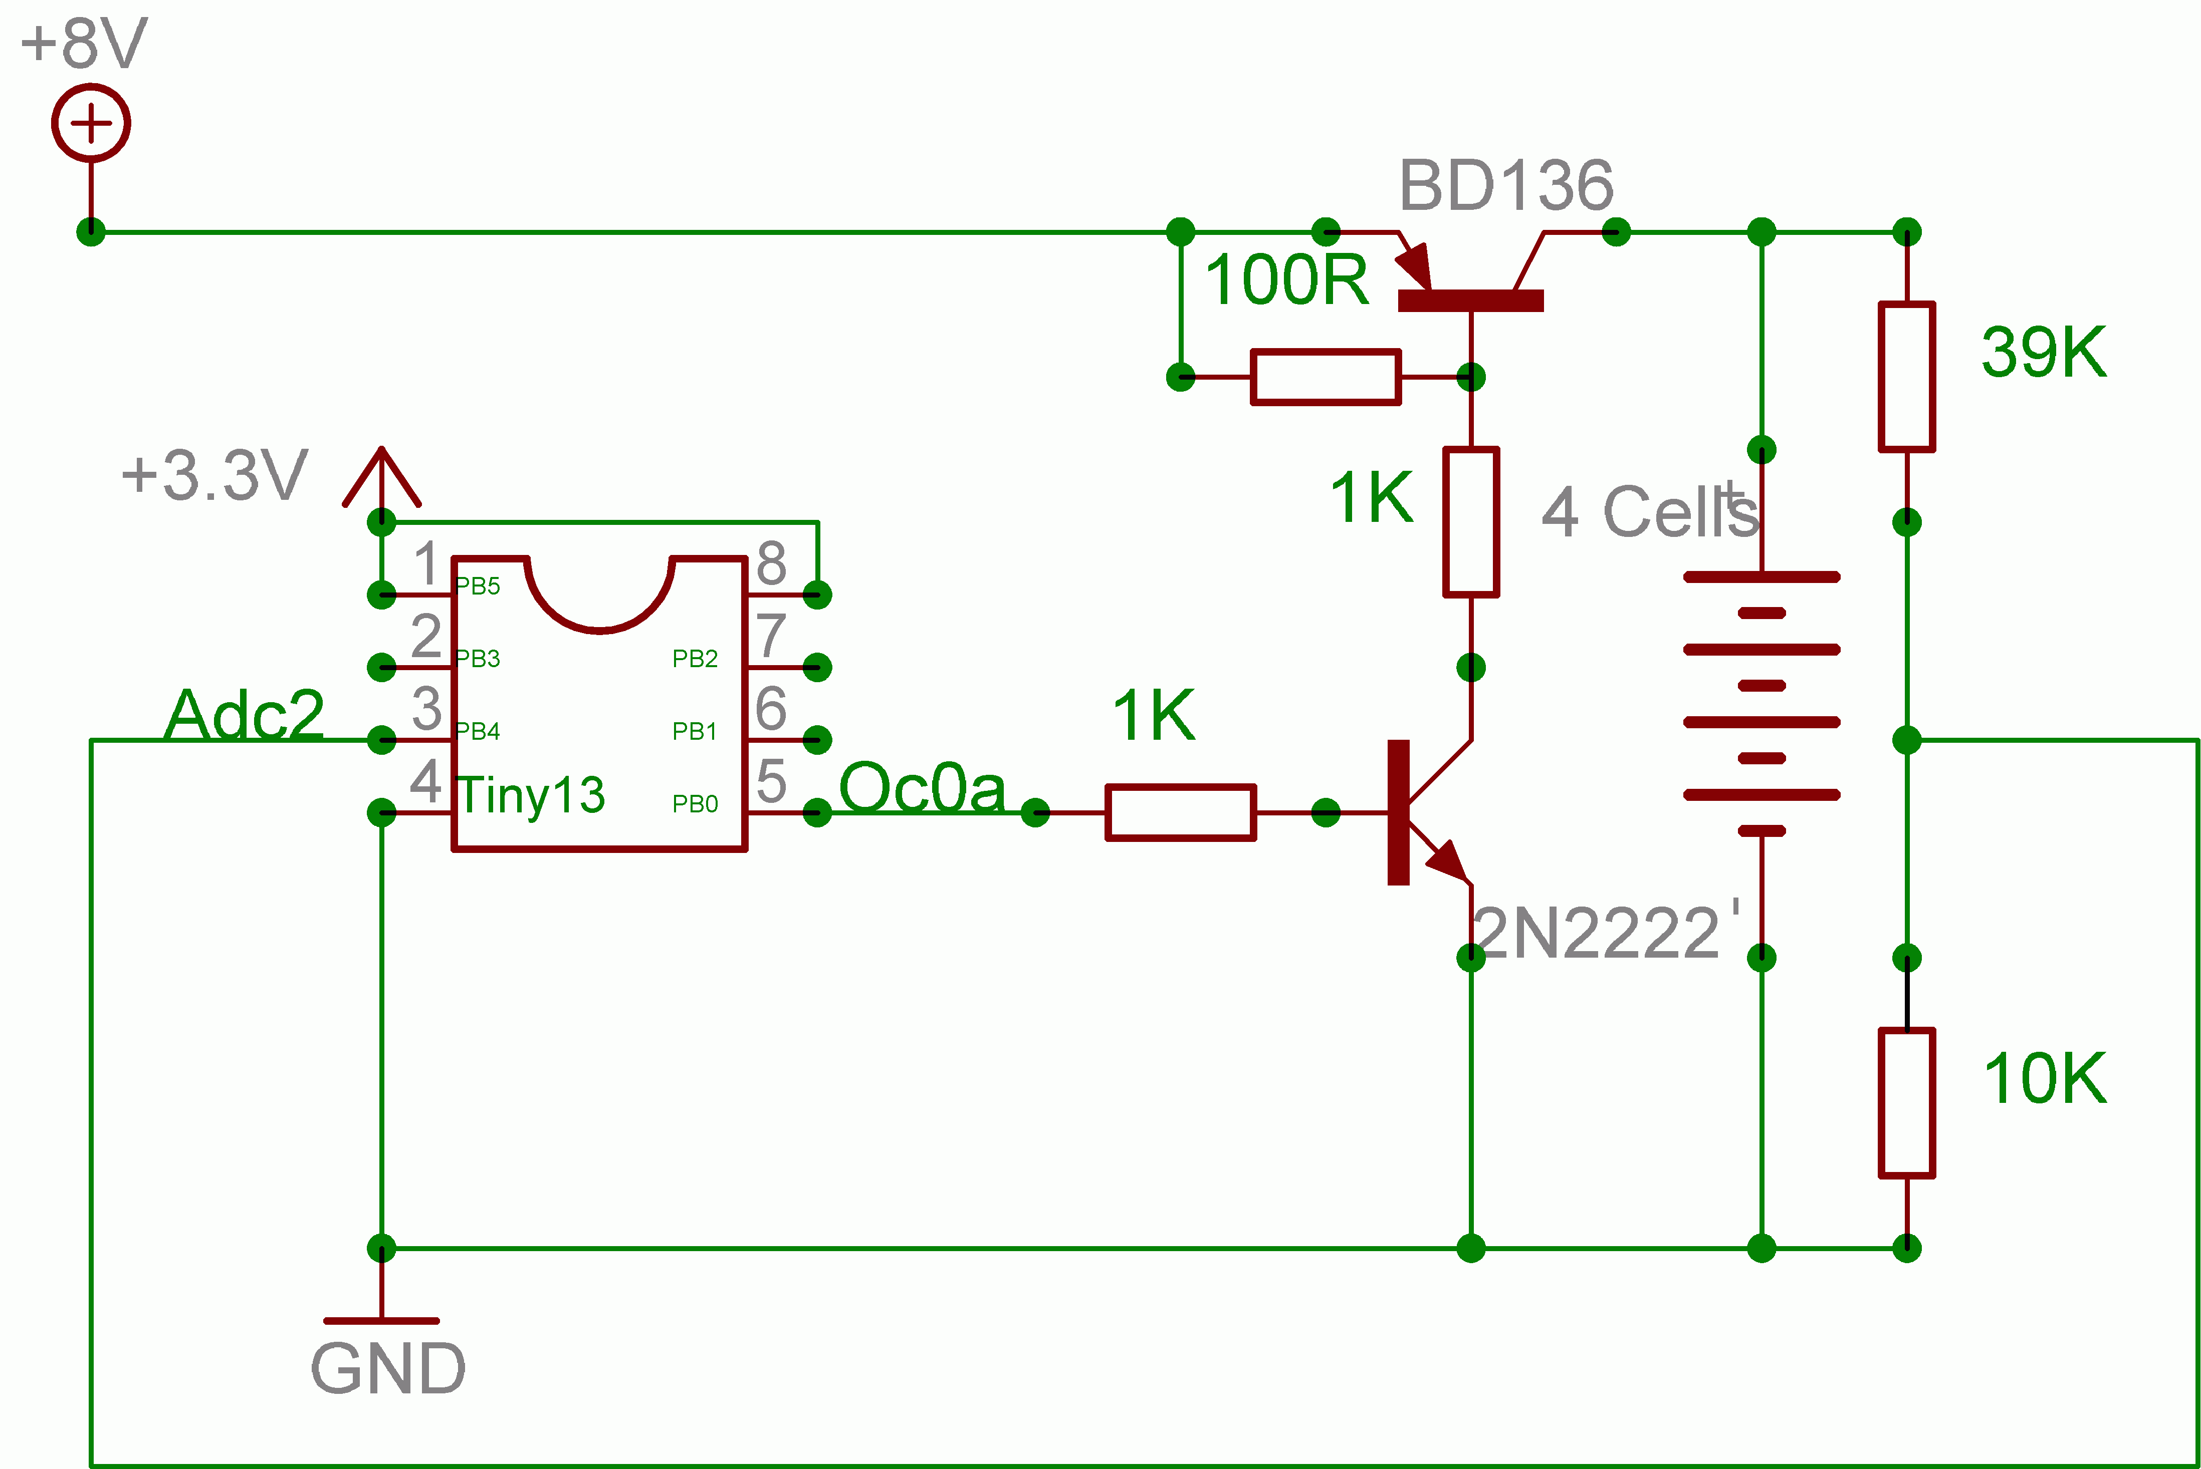

Figure 3

All the best and enjoy the experience.

John-Alfred Ullasmann

